The code I added:

In fcntl.h:



In stat.h:



In sysfile.c:

Line 257:



Line 308:

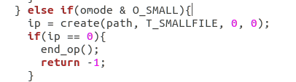

In fs.c:

line 470:

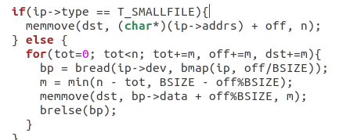

Line 502:

